Power Query ko simple language mein samajhte hain:

1. **Data Connectivity**
   * Alag-alag sources (Excel, SQL, web data, etc.) se data connect karne mein help karta hai.
   * Fayda: Sab data ek jagah aa jata hai, alag-alag systems ka tension khatam.
2. **Data Transformation**
   * Data ko clean aur change karne ka easy tool, bina coding ke.
   * Fayda: Analysis ke liye data ready ho jata hai aur time save hota hai.
3. **Automation with Queries**
   * Repeat hone wale kaam ko automate karta hai.
   * Fayda: Manual kaam kam hota hai aur speed badhti hai.
4. **Integration with Power BI**
   * Power BI ke saath milke dashboards aur reports banata hai.
   * Fayda: Data se lekar visualization tak ka kaam fast aur easy ho jata hai.
5. **User-Friendly Interface**
   * Drag-and-drop aur simple tools use karne ka option hai.
   * Fayda: Non-coders ke liye easy aur advanced users ke liye extra features.

Power bi ne Sumif, countif, avgif inko replace kardiya h calculate() me

related () -> ek table me dusri table se related jitne bhi column h use kar sakte h agar wo relation banata h

Start from need

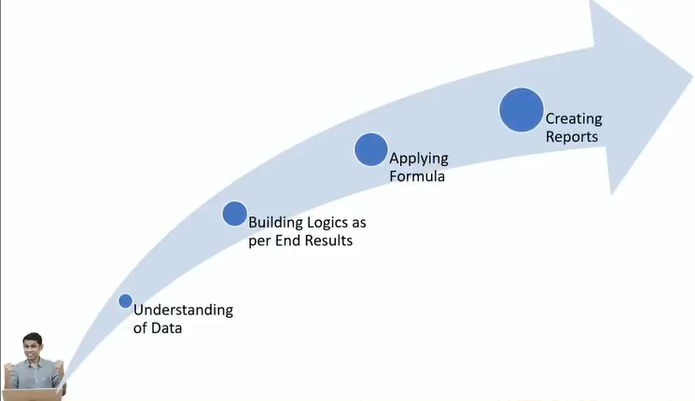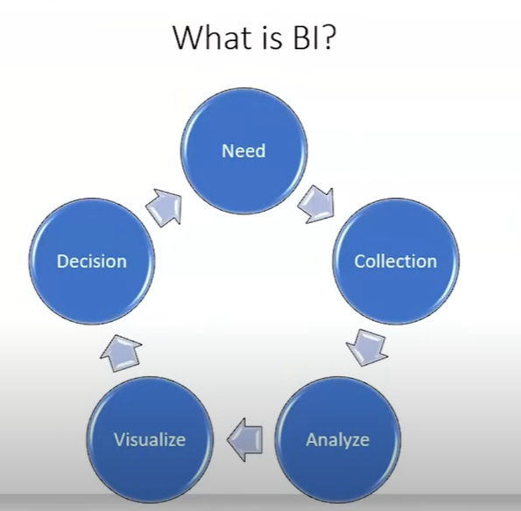

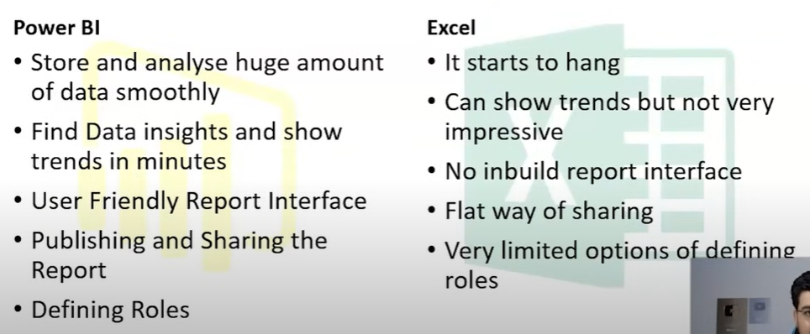

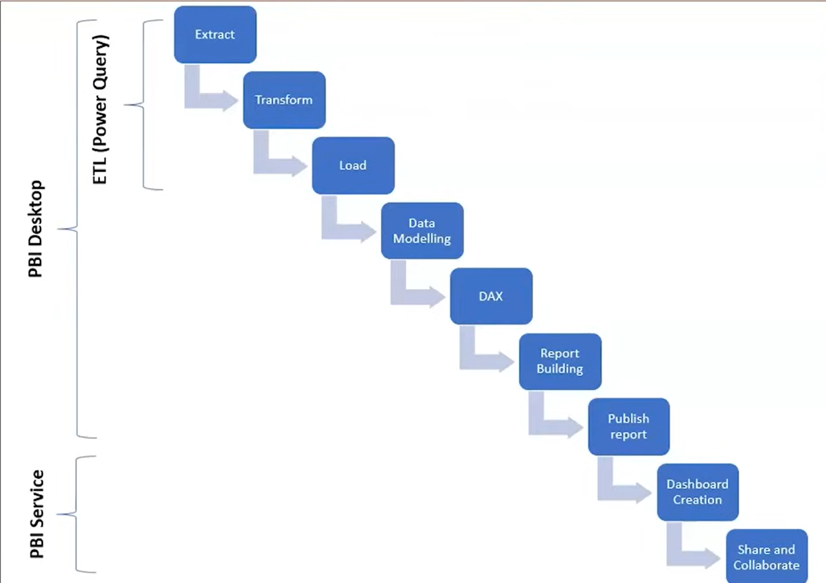

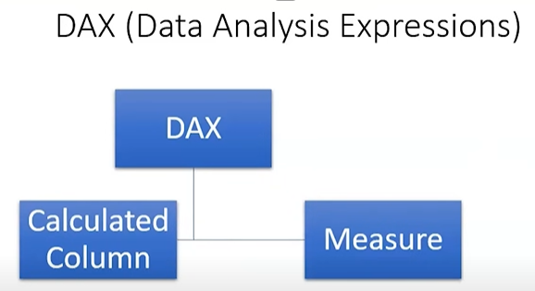

Measure - Model k andar memory ko consume nhi karte

Extract - data ko power bi me laana

Transform - data ko naam dena, data type dekhna, full name columns merge kerna, columns add karna as required, condition lagana, power query use

Load - data ko clean karne k baad power bi me load hota h

Etl tool

Extract, transform, and load

Implicite and explicite funcs

Implicite - jisme data drag and drop karke show

Explicite - jisme data show karne k liye formula

Calculated Column ek nayi column banata hai har row ke liye, jabki Measure sirf calculations karta hai summary ya aggregation ke liye, jaise sum ya average.

Calculated Column data model mein permanently store hoti hai, jabki Measure dynamically calculate hoti hai jab report ko use kiya jata hai.

* **Calculated Column**: Har row ke hisaab se calculate hoti hai aur table mein add ho jati hai.
* **Measure**: Visualization ke time par calculate hoti hai aur memory efficient hoti hai.

Calculated Column data static hota hai, jabki Measure dynamic aur context-specific hoti hai.

Count x aur countax me boolean kaam karta h par countx filter wale me boolean kaam nhi karta h